Project Name: Snake Game

Made By: 20SW123, 20SW128.

Submitted to: Ma’am Maryam

**Problem Identification:**

**Games Now a days require a good mobile phone to run , by providing this snake game people can easily play in any device even if they have an old device with old software.**

**Problem Solution:**

**This snake game will run on any device IOS or Android who’s having the oldest version possible.**

**Responsive UI:**

**People can easily interact with the game by just pressing the play button the game will start and they can move the snake by pressing the up, down, right, left arrow buttons.**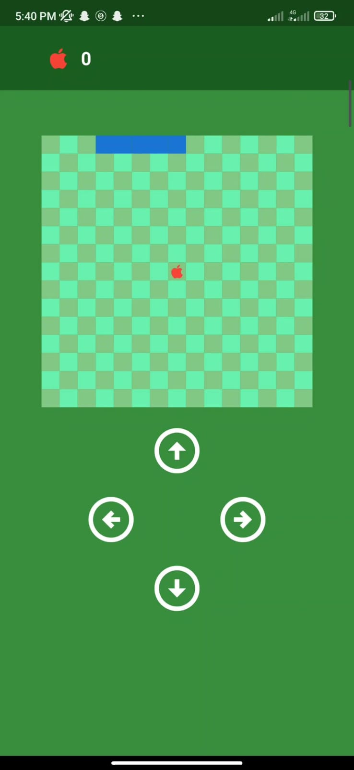

**Issues And Bugs:**

**The Problem which is occurring is that , the snake can’t bite itself so that the game gets over, and if the snake is going in any wall so it doesn’t come back from the parallel wall.**